Media Release

Farewelling a new cohort of Australia Awards Scholars

A new cohort of Australia Awards scholars from Vanuatu will shortly depart for Australia to begin their studies.
Deputy Australian High Commissioner Ms Clemency Oliphant addressed scholars preparing to travel to Australia at a briefing held in Port Vila.
“I want to congratulate each and every one of you for displaying exceptional academic achievement and commitment to the development of Vanuatu, which has resulted in you being named Australia Award scholars for 2022,” said Deputy High Commissioner Oliphant.
23 Australia Awards scholars were selected in 2022 to study in both Australia and Fiji. From over 400 applicants they were selected through a rigorous screening and interview process. The eight scholars travelling this month are the first to mobilise and will be joined in Australia by 11 fellow awardees in January 2023. Four remaining students will depart for Fiji in early 2023.
Diandra Nimoho, one of the departing scholars who will soon commence studies in Psychological Science at James Cook University, said she was excited to start her studies in Australia.
“I want to learn how people function and chose to study psychology as mental health is a field much needed in Vanuatu,” said Ms Nimoho.
Part of the selection criteria requires that awardees have either already been contributing to Vanuatu’s development and growth through their work or that their studies will position them to do so upon their return.
“Being an Australia Awards scholar is about more than just achieving an academic qualification, it is about representing your country and at the same time forming a relationship with Australia,” said Deputy High Commissioner Oliphant.
“It is also about contributing to the development of your home, Vanuatu.
“We value the close people-to-people links that are fostered when ni-Vanuatu students study in Australia, by sharing your culture and your ideas and learning more about Australian cultures and values,” said Deputy High Commissioner Oliphant.
The awardees will pursue further studies in key fields aligned to the Vanuatu Sustainable Development Plan 2030 and the Vanuatu Human Resource Plan, including public policy, finance, development studies, psychology, biomedical science, and engineering. Of the eight awardees, three will be undertaking postgraduate studies and five at the undergraduate level.
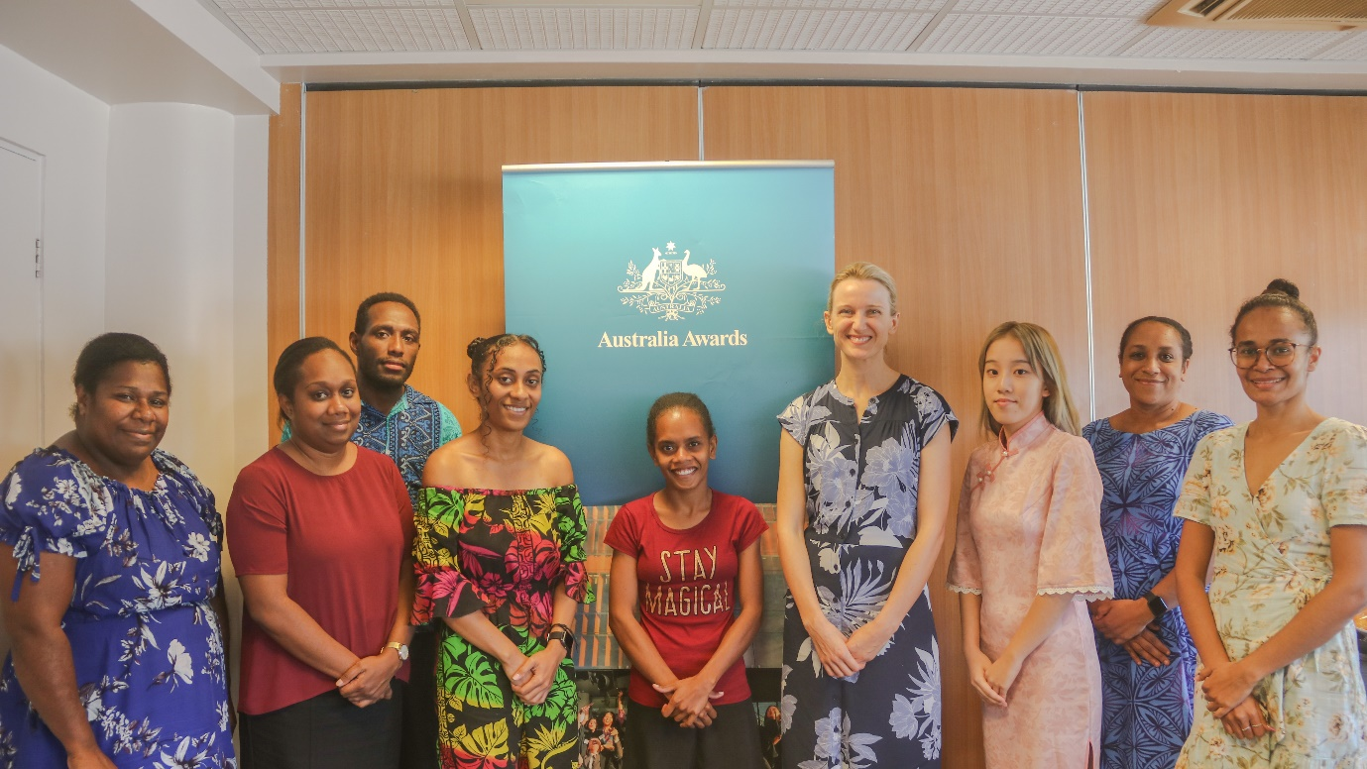
Caption: Australia’s Deputy High Commissioner, Ms Clemency Oliphant with the Australia Awards Scholars
The pre-departure briefing prepared the scholars for their time in Australia, providing them with skills and insights for their new adventure.
It provided essential information for studying abroad, tips on coping with academic life and adjusting to a new culture and climate and keeping a study-life balance. Several Australia Awards Alumni attended the briefing and shared their own experiences living and studying in Australia.
Fred Samuel, who graduated with a Diploma in Electrical Engineering at TAFE Queensland in 1997 and then a Masters in Science under the Chevening Scholarship program in 2003, advised the outgoing scholars to be an active part of their university community.
“Try to represent Australia Awards and Vanuatu at every chance that you get,” said Mr Samuel, who now works as Chief Executive Officer and Director of Pacific Group Ltd.
Australia Awards are prestigious awards aimed at building global leaders who will become leaders for sustainable development and promote people-to-people links with Australia and the Pacific.
Australia has provided more than 2,000 Australia Awards Scholarships and Fellowships to Vanuatu over the past 40 years, and there are currently 38 Ni-Vanuatu students on scholarship in Australia and the region.
Australia Awards scholarships address human capacity needs in Vanuatu and build people-to-people links. If you are interested in applying for the Australia Awards Scholarship, please visit: www.australiaawardsvanuatu.org

–END–
To know the latest about Australia in Vanuatu please follow us on:
Web | Facebook | Twitter

Media Contact:

Ellenson Taurakoto
Public Affairs Officer
Australian High Commission
Email: Elizabeth.Harris@dfat.gov.au
Tel: 22777 (extension 171)
Mob: 7776386

